e-Parliament Programme
“AM Batch” Delivery
PURE-XML UDI RULES

Changes Follow-Up
Version | Date | Author(s) | Description
1.0 | 16/1/2013 | PROMS  PAPACHRISTOS Kosmas | Creation
1.1 | 18/1/2013 | GIANNARIS Nikolaos  PAPACHRISTOS Kosmas | Correction of the examples in 1.2
2.0 | 25/1/2013 | GIANNARIS Nikolaos  PAPACHRISTOS Kosmas | Modifications after feedback from stakeholders
2.1 | 30/1/2013 | GIANNARIS Nikolaos  PAPACHRISTOS Kosmas | Internal review
2.2 | 19/03/2013 | GIANNARIS Nikolaos | Change of UDI format  Renaming of the "Interim" to "Delivery"  Change of “Scheme” from lower to upper case letters  Change of XML Rendition “Name” property from “text_xml” to “text_xml4ep”

References
ID | Title | Version | Status | Description
[1] | “AM List” Interim Solution  Policy Side Process | 1.1 | Draft | TO-BE process for the part of the AM Batch delivery solution that specifically refers to the creation and verification within DLA (using the new e-Parliament component DST) of AM documents.
[2] | “AM List” Interim Solution  Translation Process | 1.2 | Draft | TO-BE process for the part of the AM Batch delivery solution that specifically refers to the translation of AM documents
[3] | “AM List” Interim Solution  IT System View | 1.1 | Draft | Technical aspects of the “AM Batch” delivery solution, IT workflow and interdependencies of the applications involved.
[4] | PURE-XML Functional Specifications | 1.8 | Validated | Functional specifications of the Parliament Unique Repository for XML text production (PURE-XML).
[5] | Final Consolidation Ultimate IRO model.doc | 1.8 | Validated | Technical analysis made by the working groups of the IROs in order to prepare decisions, positions or recommendations for document management in the European Parliament
[6] | e-Parliament_AM-List_Interim_PURE-XML_Storage-Guidelines.doc |  |  | PURE-XML structure and guidelines to be followed for storing in PURE-XML

Table of Contents
1 UDI and Versioning of Logical and Physical Units 7
1.1 Definitions 7
1.1.1 UDI (Unique Document Identifier) 7
1.1.2 FRBR (Functional Requirements for Bibliographic Records) 7
1.1.3 UBI (Unique Business Identifier) 8
1.2 Baseline 8
1.3 Versioning rules 8
1.4 PURE-XML storage rules 9
1.5 Reusability and amendments lifecycle 10
1.6 Implementation requirements 10
1.6.1 Definition of a mapping between XML instances and PURE-XML objects 11
1.7 Advantages and remarks 14

List of Figures
Figure 1: Mapping between XML instances and PURE-XML objects 11
Figure 2: Example of PURE-XML objects and their Name and UBI properties 12
Figure 3: Mapping between media files and PURE-XML objects 13

UDI and Versioning of Logical and Physical Units
This chapter explains the usage of the document identifiers in the scope of e-Parliament, the versioning management rules and constraints, as well as the necessary provisions to implement the above mentioned document management pattern.

Definitions

UDI (Unique Document Identifier)
The structure of the UDI, as defined by the IROs is the following:
eu.europa.europarl_DIN1_2013_0123456789
Authority
Scheme
Year
Sequential number

"A UDI shall be attributed to each logical document produced and registered by the European Parliament. All representations of the same logical document (usually files containing text, irrespective of format, support, language, status, stage of evolution, or version) shall carry the same UDI, in both human and machine-readable forms"
Authority: Fixed to "eu.europa.europarl"
Scheme: The scheme is followed by the scheme version (currently "1"). The semantics of the identification scheme values are defined in the table below:
DIN1 | Documents | IRO position (2) | In the context of this delivery, assigned to AM List documents
IBI1 | Information Blocks | IRO position (28) | In the context of this delivery, assigned to individual amendments
ICI1 | Chunks | XML4EP extension | Not used in this delivery
IMI1 | Media Files | XML4EP extension | Used for images, audio/video files, etc.
Year: The value of the calendar year in which the UDI was created
Sequential number: 10-digits, reset to "0000000001" every year on December 31st midnight.

FRBR (Functional Requirements for Bibliographic Records)
FRBRs are used by the identification model of Akoma Ntoso schema. The following three levels are used:
- FRBRWork: the abstract concept of the legal resource. Corresponds to the UDI.
- FRBRExpression: any version of the Work (whose content is specified and different from others for any reason: language, versions, etc.)
- FRBRManifestation: any electronic or physical format of the Expression: word, xml, Tiff, pdf, etc.
The values of those identifiers are defined by XML4EP.

UBI (Unique Business Identifier)
UBI is a PURE-XML system property. It has to be unique and it is mandatory for all the PURE-XML objects. The values to be used for this property are defined in the following paragraphs.

Baseline
The proposed solution is designed to be aligned with and support the following baseline:
- XML Akoma Ntoso schema and, more specifically, the requirement of Akoma Ntoso to include their own identifier inside the XML instances
- The PURE-XML data model which is based on IROs model (see for more details) and the corresponding versioning functions

Versioning rules
As mentioned in the previous paragraph, the versioning rules originate from the IROs model which defines the following notions:
- Content versioning: “A form of a physical document that differs (has been changed) either in the wording within the same language or in metadata values of the semantic message of a logical document. The form of the physical document represents a stage in the elaboration of the semantic message of a logical document.”
- Language correction: “A form of a physical document that differs (has been changed) either in the wording within the same language or in metadata values of the semantic message of a logical document. The form of the physical document represents a stage in the translation of the semantic message of another physical document by correction of the language representation.”
- Major version: “A form of a physical document that differs (has been changed) significantly in the wording within the same language of the semantic message of a logical document.”
- Minor version: “A form of a physical document that differs (has been changed) slightly in the wording within the same language of the semantic message of a logical document.”
The structure of the version identifier is the following:
01.00-en-01.00
Content major version
Content minor version
Language code
Major linguistic correction
Minor linguistic correction

On top of the above general definitions provided by the IROs, e-Parliament sets additional versioning rules/restrictions to simplify version management:
- Content/semantic versions are triggered only when the original language is modified. This means in practice that original documents can never have linguistic corrections. As a convention, the starting version is fixed to “01.00”.
- Linguistic corrections are triggered only when the translations are modified. This means in practice that translations (of a specific version of the original document) will all have the same content version. However, linguistic corrections among languages (for the same content version) can have different “linguistic correction” values, simply because each translation unit may create one or more linguistic corrections during the translation process.
- By default, new content versions and linguistic corrections increase the corresponding minor number. Client applications control the major part (i.e. client applications just say if it is major version or not) based on business-defined rules. These rules can be defined independently by each application owner.
The following examples illustrate the effect of the above rules:
- For the “en” as original language the following are possible versions (for the same document):
  - 01.00-en-01.00
  - 01.02-en-01.00
  - 02.00-en-01.00
- Knowing the content version identifier of a translation we always know the version of the original (we assume that the original language code is “en”) :
TRANSLATION à ORIGINAL
01.01 – fr – 01.05 à 01.01 – en – 01.00
02.00 – pt – 01.00 à 02.00 – en – 01.00

PURE-XML storage rules
Storage in PURE-XML will be done respecting the following rules:
- Each amendment list is a different logical unit
- Each amendment is a different logical unit
- Logical units will not have other logical units as children. This is applied in order to avoid duplicating the “inclusion” relationship between parents and children which is already defined inside the XML instances (the XML of the AM List document contains references to the individual amendments).
- Logical units will be grouped in folders. The folder hierarchical structuring must be globally defined and has to be respected by the client applications (see [6] for more details). This structure will facilitate the management of access control.
- No bottom-up relationships. For amendments this means that an individual amendment is "unaware" of the AM list it belongs to (N.B. the same individual amendment can be included in more than one AM List or even in documents of different type such as AM and RR). Currently, no business need has been identified to set up and maintain this kind of relationship. If this need arises in the future, PURE-XML is able to support it. However, even without bottom-up relationships, the information of which AM lists (or other types of “containers”) containing a given individual amendment can still be retrieved ad-hoc via other means.

Reusability and amendments lifecycle
Reusability of amendments is not in the scope of the e-Parliament AM Batch delivery; however it is enabled for amendments that have been translated in XML and stored in PURE-XML. In order to facilitate future reusability, two basic rules have been defined:
- Each amendment (the full version series) shall be related to only one base document (e.g. COM document, including all its potential versions) in the same procedure. For COD procedures, this covers both first and second reading. If the amendment is reused in a different procedure, it must trigger the creation of a new amendment (which is assigned a new UDI).
- The same version of an amendment can be included in multiple amendment lists. A typical example is the amendments that are voted at the committee stage and re-appear without any modification at the plenary stage.

Implementation requirements
In order to implement the theoretical schema and rules described above, certain technical details have to be settled. The following paragraphs explain how the XML instances will be saved in PURE-XML and what is required by the client applications.

Definition of a mapping between XML instances and PURE-XML objects
The following figure illustrates the mapping between Akoma Ntoso XML instances and PURE-XML objects. This mapping is applied to any XML instance, i.e. regardless if it is an individual amendment, an AM List or other.
The FRBRWork, FRBRExpression and FRBRManifestation XML4EP identifiers should be mapped respectively to the "Universal Business Identifier" (UBI) property of the Logical Unit, Physical Unit and XML Rendition PURE-XML objects.
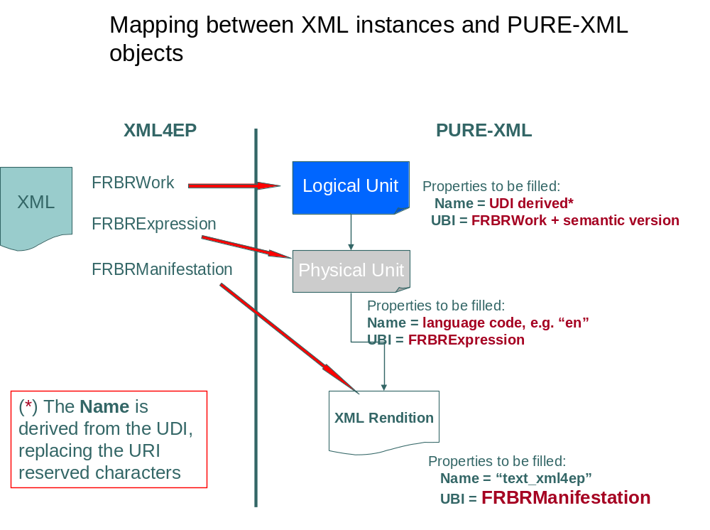
Figure 1: Mapping between XML instances and PURE-XML objects
N.B.: The UDI contains characters that are considered as reserved characters for the URIs. The "Name" property will be identical to the UDI after converting all the reserved characters to underscore ("_"). Multiple reserved characters shall be converted to a single underscore.
The diagram below presents an example of PURE-XML objects and their name and UBI properties:

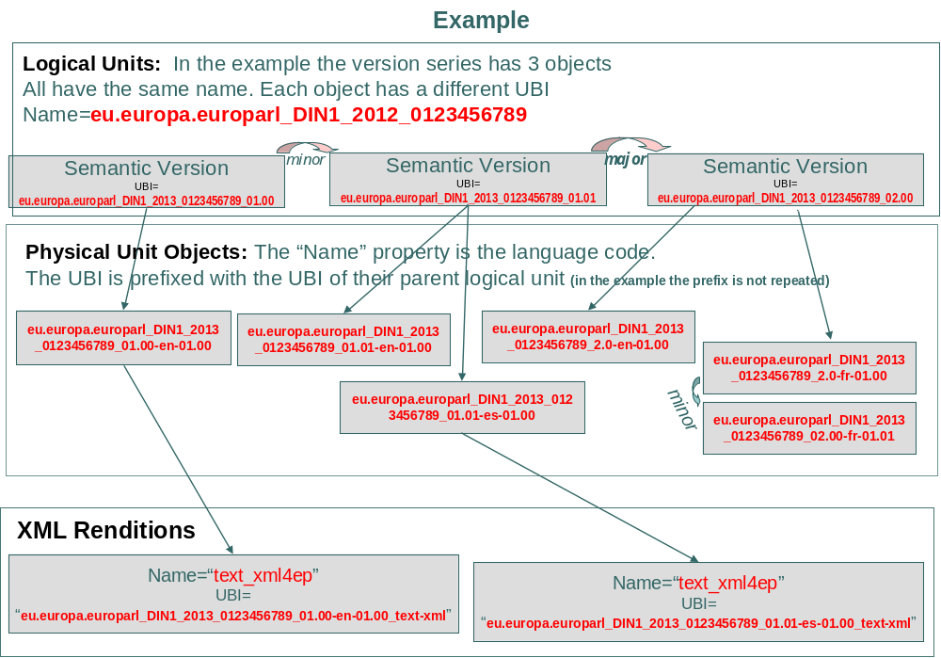
Figure 2: Example of PURE-XML objects and their Name and UBI properties

The next figure illustrates the mapping between media files and PURE-XML objects. Media files should also be assigned a UDI and can be versioned. They are stored separately in PURE-XML (NOT as another child of the XML instance's Physical Unit) and are referenced by the XML instances. Again the storage requires three PURE-XML objects and the "mapping" is similar:
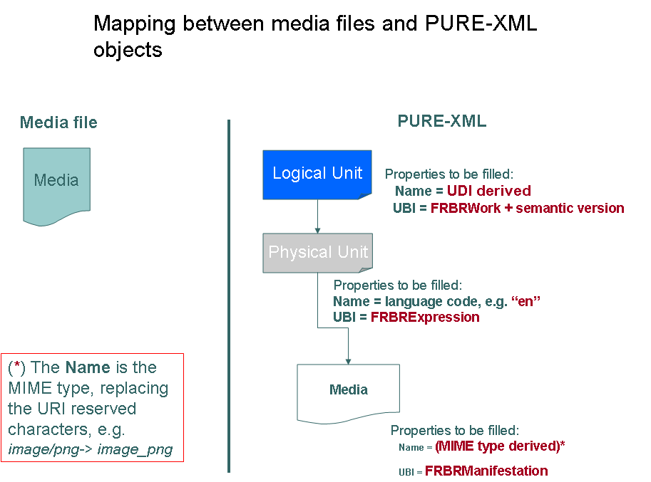
Figure 3: Mapping between media files and PURE-XML objects

Technical and business constraints
- All applications must use only the UBI as official identifier for referencing XML4EP instances
- What is exchanged/circulated among client applications is the UBI of the XML rendition or media objects in PURE-XML
- The PURE-XML versioning methods will guarantee the sequential execution of concurrent save attempts (i.e. only one application will be able to check-out an object at each given moment). Each content modification (semantic version or linguistic correction) will trigger the creation of a new version in PURE-XML.
- All XML instances will be saved in different PURE-XML physical units. This means that the storage of an XML instance that references other content requires that the referenced content is already stored in PURE-XML (so that the correct/latest UBI is inserted in the XML code).
Example: To store an AM List, all individual amendments have to be stored first in PURE-XML and their references (returned by PURE-XML) must be inserted in the AM List XML instance. References will not be controlled (i.e. if they exist or not).
- Media files will be saved in different PURE-XML logical units. Referencing media from an XML instance requires that the media is saved first, as described above.
- Modifications of sub-documents that are contained in other documents (e.g. amendments that are contained in AM Lists) will not trigger automatically modification of the parent document. If such a modification is necessary, it has to be requested explicitly afterwards.
Example: When an amendment of an AM list is updated, the version of the individual amendment increases which means that the UBI of the rendition is changed. In principle, the new UBI is not replaced automatically in the AM List and therefore the version of the AM List document does not change. If and when the user/client application wishes to "update" the AM List document with all the changes done in the AM List, a new version of the AM List is explicitly saved, with the new UBIs inserted.

(N.B. Paragraph describing saving in PURE-XML removed; see deliverable [6] "PURE-XML Storage Guidelines")

Advantages and remarks
- All client applications will be able to see/reuse all the content versions, e.g. AT4AM could reuse the text after all modifications (verification, MeF, etc.).
- DG TRAD will be able to detect and reuse (replace) automatically already translated text.
- The versioning rules are (in principle) application-independent. DST/AT4AM might also control the linguistic corrections and CAT4TRAD might control the semantic version. For example, in some cases DLA can verify all linguistic versions and DG TRAD can verify the original.
- A rule has to be defined for the “latest” or “active/booked-out” translation in case it is not always PURE-XML's latest version. This is up to the client applications to define and maintain. PURE-XML can support such functionality using "Tags" on the objects.
- The original language is stored as metadata in each XML4EP instance. PURE-XML also offers an "original language" property. Support for the pivot language exists in Akoma Ntoso and can be provided by PURE-XML (e.g. using a content-type property), if such a need arises.
- For new content versions of already translated text re-submitted for translation, it is up to CAT4TRAD to decide the pre-translation/pre-fill strategy, whether it will use the translation of the previous version or if it will match the text as today using Euramis.
Further analysis is needed to identify business and/or technical needs for the definition of Relationships (e.g. bottom-up usage relationships, i.e. amendment “belongs to”, “voted in” etc.) and Tags in PURE-XML.

For example, on a technical level, one potential usage of a bottom-up relationship would be to identify "active" content, i.e. which amendments are "still in use" and included in an amendments list.
The detailed definition of the reserved characters is in http://www.ietf.org/rfc/rfc3986.txt (URI Generic Syntax)

